**WORKFORCE ADMINISTRATION SOLUTIONS(Dev)**

Team ID: LTVIP2025TMID30609

Team Size: 4

* Team Leader:  Hansika Manem

Email: [24pa5a4507@vishnu.edu.in](mailto:24pa5a4507@vishnu.edu.in)

* Team member: Avupati Ganesh

Email: [23pa5a0501@vishnu.edu.in](mailto:23pa5a0501@vishnu.edu.in)

* Team member: Alluri Chandra Aditya

Email: [Chandraaditya1470@gmail.com](mailto:Chandraaditya1470@gmail.com)

* Team member: Bonthu Deepak

Email: [23Pa5A1202@vishnu.edu.in](mailto:23Pa5A1202@vishnu.edu.in)

**PROJECT INDEX**:

1. **IDEATION PHASE**:

Problem Statement

Empathy Map Canvas

Brainstorming

1. **REQUIREMENT ANALYSIS: Customer Journey map**

Solution Requirement

Data Flow Diagram

Technology Stack

1. **PROJECT DESIGN:**

Problem Solution Fit

Proposed Solution Solution Architecture

1. **PROJECT PLANNING: Project Logic**

Project Planning

1. **FUNCTIONAL AND PERFORMANCE TESTING**: Performance Testing
2. **ADVANTAGES & DISADVANTAGES**
3. **CONCLUSION**

GitHub & Project Demo Link

**Ideation Phase**

**Brainstorm & Idea Prioritization**

|  |  |
| --- | --- |
| Date | 24 June 2025 |
| Team ID | LTVIP2025TMID30609 |
| Project Name | Workforce Administration Solution(dev) |
| Maximum Marks |  |

1. Brainstorming:
   * + Define the Problem:

Clearly articulate the specific challenges in workforce administration that the Salesforce solution aims to address (e.g., inefficient onboarding, lack of centralized employee data, inaccurate time tracking).

* + - Gather Participants:

Include stakeholders from HR, IT, management, and potentially even employees to get diverse perspectives.

* + - Use Brainstorming Techniques:

Employ techniques like:

* + - Mind Mapping: Visually organize ideas and their connections.
    - Brainwriting: Participants write down ideas individually before sharing, promoting more diverse contributions.
    - SCAMPER: Use prompts like Substitute, Combine, Adapt, Modify, Put to other uses, Eliminate, and Reverse to spark new ideas.
    - Encourage Free Thinking:

Create a safe space for all ideas, even seemingly unconventional ones, without judgment.

* + - Document Everything:

Record all ideas, even those that might not be immediately pursued, for future consideration.

1. Idea Prioritization:
   * + Establish Criteria:

Define clear criteria for evaluating ideas, such as:

* + - Business Impact: How much will the solution improve efficiency, reduce costs, or increase revenue?
    - Feasibility: Can the solution be implemented with existing resources and technology?
    - User Benefit: How will the solution improve the experience for employees and administrators?
    - Alignment with Business Goals: Does the solution support overall business objectives?
    - Technical Complexity: How complex is the solution to build and maintain?
    - Prioritization Frameworks:
    - MoSCoW Method: Categorize ideas as Must have, Should have, Could have, and Won't have.
    - Impact/Effort Matrix: Plot ideas on a matrix based on their impact and effort required for implementation. High impact/low effort ideas should be prioritized.
    - Forced Ranking: Rank ideas against each other based on the chosen criteria.
    - Salesforce Ideas Exchange: Utilize the Salesforce Ideas Exchange to gauge community interest and gather feedback on specific ideas.
    - Stakeholder Input:

Involve key stakeholders in the prioritization process to ensure alignment and buy-in.

* + - Transparency and Communication:

Communicate the prioritization process and results clearly to all stakeholders.

* + - Regular Review:

Revisit priorities regularly to adapt to changing business needs and user feedback.

1. Implementation Planning:
   * Develop a Roadmap: Create a phased implementation plan based on the prioritized ideas.
   * Assign Ownership: Clearly assign ownership and responsibility for each task.
   * Track Progress: Use project management tools to track progress against the plan.
   * Monitor and Evaluate: Continuously monitor the impact of implemented solutions and evaluate their effectiveness.
   * Gather User Feedback: Establish a feedback loop to collect user feedback and identify areas for improvement.

By following these steps, you can effectively brainstorm, prioritize, and implement a Salesforce workforce administration solution that meets the needs of your organization and drives positive outcomes.

**Ideation Phase**

**Empathize & Discover**

|  |  |
| --- | --- |
| Date | 24 June 2025 |
| Team ID | LTVIP2025TMID30609 |
| Project Name | Workforce Administration Solution(dev) |
| Maximum Marks |  |

Empathy Map:

Here’s a tailored Empathy Map for a Workforce Administration Solution within the context of a Salesforce project. This map helps align design decisions with the real needs and experiences of core users, especially useful for discovery, requirement gathering, and user story development.

Empathy Map – Workforce Administration Solution (Salesforce Project)

Primary Persona: HR Manager

Project Context: Implementing a centralized HR/workforce administration solution using Salesforce (Service Cloud, Experience Cloud, Flow, Analytics, etc.)

THINK & FEEL

What is the user really thinking and feeling? What matters to them deeply?

* "There’s too much manual work—this should be automated."
* "We need a reliable system that integrates everything."
* "I worry about compliance—what if we miss a legal deadline?"
* "I want better visibility into workforce trends (turnover, leave, performance)."
* "Is this going to make my job easier or harder?"

SEE

What does the user see in their environment, team, or tech stack?

* Disconnected tools (Excel sheets, email approvals, legacy HR systems).
* Delays in onboarding and approvals.
* Complaints from employees about lack of visibility.
* Leadership demanding real-time reports and HR insights.
* Inconsistent processes across departments.

SAY & DO

What does the user say and do outwardly? How do they behave?

* "We need everything in one place—leave, attendance, performance."
* "It takes too long to approve and process requests."
* Frequently follows up with IT or admins for reports or bug fixes.
* Reaches out to managers to remind them of pending approvals.
* Advocates for automation and better reporting tools.

HEAR

What are they hearing from colleagues, employees, and leadership?

* "Why is my onboarding delayed?"
* "I submitted my leave request days ago."
* "We can’t keep up with manual HR work anymore."
* "We need better insights for workforce planning."
* "Is HR even tracking this?"

PAIN

What are their biggest frustrations, fears, or obstacles?

* Manual, error-prone processes (leave, attendance, onboarding).
* Time-consuming reporting and lack of live dashboards.
* Overwhelmed by compliance tracking.
* Inefficiency from using multiple platforms.
* Low trust in the accuracy of current HR data.

GAIN

What does success look like? What do they hope to achieve?

* Centralized, automated HR process using Salesforce tools.
* Integration with payroll, benefits, and finance systems (via MuleSoft).
* Mobile access and self-service capabilities for employees.
* Clear dashboards and reports using CRM Analytics.
* Improved productivity and HR response time.
* High employee satisfaction and lower attrition.

|  |  |
| --- | --- |
| Need/Insight | Salesforce Feature to Address It |
| Workflow automation | Salesforce Flow, Process Builder |
| Real-time analytics | CRM Analytics (Tableau CRM) |
| Self-service for employees | Experience Cloud |

, ' e@How to Apply This in the Salesforce Project

Case management & issue tracking Service Cloud, Omni-Channel

Data integration MuleSoft, External Services, Platform Events

Compliance logging Salesforce Shield, Field History Tracking

|  |  |
| --- | --- |
| Use Case | User Pain/Gain Addressed Salesforce Tool Used |
| Automated onboarding flow | Pain: Manual process Flow + Experience Cloud |
| Leave request and approval workflow | Pain: Delays and confusion Flow + Custom Objects |
| HR ticketing system    Employee performance | Pain: Missed employee Service Cloud + Email-to-  queries Case |

■v Use Case Mapping from Empathy Insights

Gain: Data-driven decisions CRM Analytics

|  |  |  |
| --- | --- | --- |
| Real-time compliance alerts | Pain: Risk of non-    compliance | Shield + Notification  Builder |

dashboard

Would you like a visual empathy map PDF or editable version (Miro, Lucidchart, Figma) to include in your Salesforce project documentation or presentation deck?

**Ideation Phase**

**Define the Problem Statements**

|  |  |
| --- | --- |
| Date | 24 June 2025 |
| Team ID | LTVIP2025TMID30609 |
| Project Name | Workforce Administration Solution(dev) |
| Maximum Marks |  |

The current workforce administration processes are highly fragmented, relying on disconnected tools such as spreadsheets, emails, and legacy systems to manage onboarding, leave, performance tracking, and HR case management. This results in inefficiencies, data silos, manual errors, and inconsistent workflows across departments. HR teams are overwhelmed with repetitive, manual tasks that delay approvals, reduce productivity, and increase the risk of non-compliance. Moreover, employees lack access to self-service tools for basic HR needs, leading to frustration and increased support queries. Business leaders are also unable to make timely, data-driven decisions due to limited real- time visibility into workforce metrics. Additionally, the absence of integration between HR systems and payroll or finance platforms leads to duplicate data entry and frequent mismatches. These challenges collectively hinder operational efficiency, reduce employee satisfaction, and expose the organization to compliance risks. Therefore, the organization needs a unified, automated workforce administration solution built on Salesforce to centralize processes, enable self-service, integrate systems, and provide real-time insights for strategic decision-making.

Example:

Current manual workforce administration processes, including time tracking, leave management, and performance reviews, are inefficient and error-prone, leading to increased administrative overhead, inaccurate data, and delayed decision-making. This negatively impacts employee morale and overall organizational productivity."

Aspect Details

Workforce processes (time tracking, leave, performance reviews)

Current Situation

are manual.

|  |  |  |
| --- | --- | --- |
| Challenges | * Inefficiency in HR operations * Prone to human error * Delayed approvals and reviews | |
| Impact | * Increased administrative workload * Inaccurate data * Slow decision-making | |
| Aspect | Details |
| Consequences | * Reduced employee morale * Lower productivity * Poor employee experience |

Streamline workforce administration through automation and

Business Need system integration.

Implement a centralized, automated Salesforce-based solution

Proposed Solution for workforce administration.

Project Phase-II

CUSTOMER JOURNEY MAP

|  |  |
| --- | --- |
| Date | 24 June 3035 |
| Team ID | LTVIP2025TMID30609 |
| Project Name | Workforce Administration Solution(dev) |
| Maximum Marks | 4 |

Customer Jouney Map:

Certainly! Below is a simplified and focused Customer Journey Map for a Workforce Administration Solution, covering key lifecycle stages: Recruit & Hire, Onboard, Engage, Develop, Progress, and Exit — specifically from the employee's perspective.

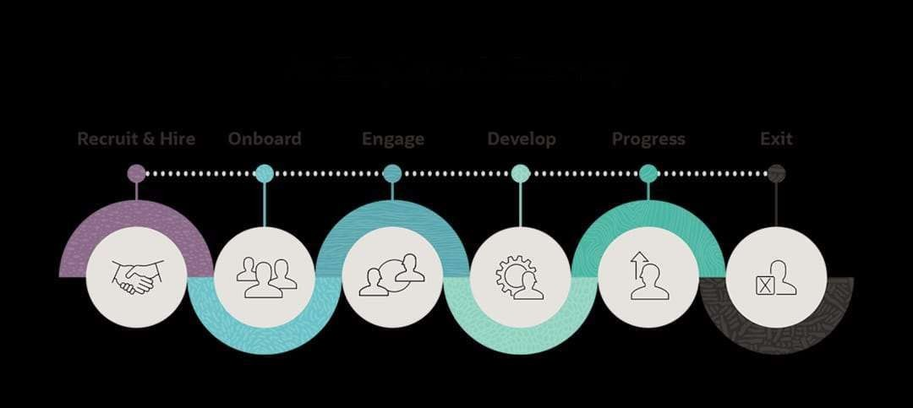

|  |  |  |
| --- | --- | --- |
| Employee  Stage Touchpoints Experience Goal | Pain Points | Opportunities for  Improvement |
| Career portal,  1. Apply and get email, interviewExcited, | Delays in updates, | Automated updates, |
| Recruit & selected for a scheduling hopeful, | unclear | candidate |
| Hire role curious  tools | application status | portal, quick feedback |

1. Join the HR portal, Overwhelmed Manual Digital Onboard company and onboarding but motivated tasks, onboarding

Opportunities

Employee

Stage Touchpoints Experience Pain Points for

Goal

Improvement

complete all checklist, e- unclear next flow, welcome

formalities signature tools steps dashboard

Access Self-service  resources,

1. portal, time Confident and Hard-to- Centralized HR Engage manage leave, self-reliant navigate services,

tracking, HR and stay systems mobile access

comms

informed

Learning

Improve skills LMS

modules, skill Eager to grow No training

1. through integration,

assessments, but needs calendar or

Develop training and personalized

learning mentorship direction tracking learning paths

tools

Advance

Irregular

1. career, Performance Motivated but reviews, 360° feedback,

|  |  |
| --- | --- |
| Progress reviews, goal-  feedback and setting tools  recognition    Exit checklist, | seeks progress  unclear  transparency dashboards  metrics      Delayed exit |

receive

|  |  |  |  |
| --- | --- | --- | --- |
|  | Leave the | feedback | Wants closure clearance, Automated |
| 6. Exit | organization smoothly | survey, document handover | offboarding,  and clarity no feedback exit analytics  loop |

**Project Requirement Analysis Phase**

**Data Flow Diagram & User Stories**

|  |  |
| --- | --- |
| Date | 24 June 2025 |
| Team ID | LTVIP2025TMID30609 |
| Project Name | workforce administration solution (dev) |
| Maximum Marks |  |

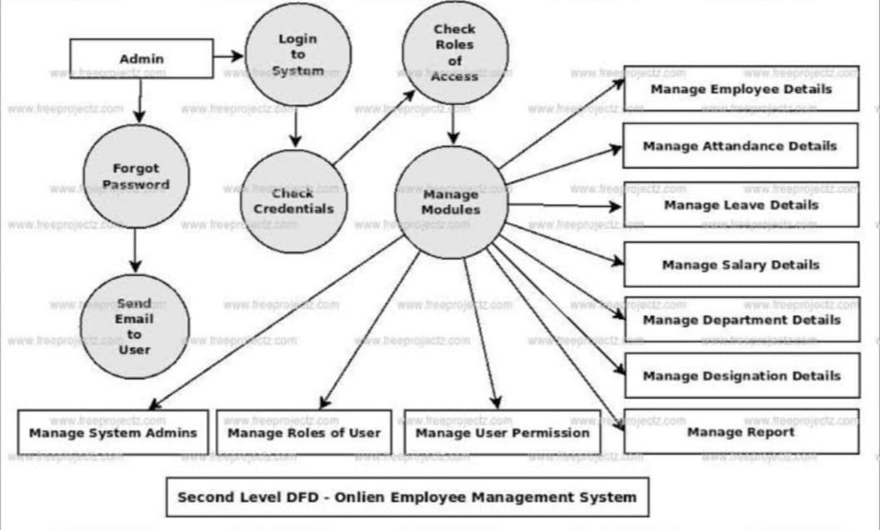Data Flow Diagrams:

A Data Flow Diagram (DFD) for a workforce administration solution would visually represent how data moves through the system, showing processes, data stores, and external entities. A basic Level 0 DFD might depict the core interactions between employees, managers, HR, and the system itself, while higher levels would delve into specific functionalities like onboarding, payroll, or performance management.

Example: [ 0 level DFD – Online Employee Management System ]

Explanation:

* Inputs:
  + Employee data from HR Department o Requests from Employees (leave applications, personal info updates)

|  |  |  |  |  |
| --- | --- | --- | --- | --- |
| User Type | Functional  Requirement  (Epic) | User Story  User Story / Task Acceptance Criteria Priority Release | | |
| Number |  |  |
| Employee | Leave  Management | USN-1 | As an employee, I want to submit leave Leave request form accessible; request requests through the portal so I can submitted successfully; confirmation High manage my time off easily. notification received. | Sprint-1 |
| Employee | Leave Management | USN-2 | As an employee, I want to view my leave  Leave balance and history displayed  balance and history so I can plan my High  accurately on dashboard.  leaves accordingly. | Sprint-1 |

* Process:
  + Employee Management System handles data storage, validation, approvals, updates.
* Outputs:
  + Reports and dashboards for HR and management
  + Updated employee records

User Stories

Use the below template to list all the user stories for the product.

|  |  |  |  |  |
| --- | --- | --- | --- | --- |
| User Type | Functional  Requirement  (Epic) | User Story  User Story / Task Acceptance Criteria | | Priority Release |
| Number | As a manager, I want to review and Manager can view pending requests; |
| Manager | Leave Approval | USN-3 | approve/reject leave requests to manage approval/rejection updates status; | High Sprint-1 |
| HR Administrator    HR | Employee  Records  Management    Compliance | USN-4 | my team’s availability. notifications sent to employee.    As an HR admin, I want to add and Employee profiles can be update employee profiles to maintain created/edited; changes saved and accurate workforce data. reflected immediately.  As an HR admin, I want to receive alerts Automated alerts sent before expiry; | High Sprint-1 |
| Administrator | Management  Workforce | USN-5 | for expiring certifications and documents dashboard shows compliance status; to ensure compliance. audit logs maintained.    As an HR analyst, I want to generate Reports accessible; data updated in | Medium Sprint-2 |
| HR Analyst    System  (Automation) | Analytics    Workflow  Automation | USN-6    USN-7 | workforce reports (headcount, attrition, real-time; export options available.  leave trends) for informed decisions.    As a system, I want to automate leave Leave workflows automated; | Medium Sprint-2    High Sprint-1 |
| approvals and notifications to reduce notifications sent promptly; exceptions manual workload and errors. flagged for manual review. |
| Employee | Self-Service Portal USN-8 | | As an employee, I want to update my Personal info editable; changes personal information through the portal validated and saved; confirmation to keep my records current. shown. | Medium Sprint-2 |

**Project Requirement Analysis Phase**

**Solution Requirements (Functional & Non-functional)**

|  |  |
| --- | --- |
| Date | 24 June 2025 |
| Team ID | LTVIP2025TMID30609 |
| Project Name | Workforce Administration Solution(dev) |
| Maximum Marks |  |

■v Functional Requirements of the Proposed Workforce Administration Solution

# Functional Requirement Description

Employee Registration and Allow HR to create, update, and manage employee records

1. Profile Management

including personal, job, and contact info.

Enable employees to apply for leave and managers to

1. Leave Management System

approve/reject requests via automated workflows.

Track employee goals, KPIs, reviews, and feedback within the

1. Performance Management

system.

Integrate time-in/time-out tracking and generate attendance

1. Attendance and Time Tracking

reports.

Provide employees with access to update personal info, view

1. Employee Self-Service Portal leave balance, and submit service requests.

Task and Workflow Automate routine HR processes like onboarding, offboarding,

1. Automation

and document approvals.

Trigger email/SMS notifications for approvals, document

1. Notifications and Alerts

expiry, birthdays, and compliance alerts.

Store, retrieve, and manage HR documents such as offer

1. Document Management

letters, ID proofs, and contracts.

Monitor document validity, policy acknowledgment, and

1. Compliance and Audit Tracking maintain audit logs.

Ensure users can only access features and data based on their

1. Role-Based Access Control

role (HR, Manager, Employee).

Provide HR and leadership teams with real-time dashboards

1. Dashboard and Reporting

and exportable reports.

Integration with External Integrate with payroll, ERP, and third-party HR systems using 12 Systems

APIs or MuleSoft.

•,' Non-Functional Requirements of the Proposed Workforce Administration Solution

Non-Functional

# Description

Requirement

The system must handle at least 500 concurrent users without

1 Performance degradation in response time.

The solution should be scalable to support future workforce 2 Scalability

expansion and additional modules.

The system should maintain 99.9% uptime to ensure HR operations

1. Availability

are uninterrupted.

The application must reliably perform HR tasks with minimal system

1. Reliability

crashes or failures.

The system must support role-based access control, encryption of 5 Security sensitive data, and comply with GDPR and local labor laws.

The application should be easy to update or modify with minimal

6 Maintainability downtime or disruption.

The interface should be intuitive and accessible for users with 7 Usability

minimal training (HR, managers, employees).

The system must perform automated daily backups and support data

8 Backup and Recovery recovery within 2 hours of failure.

All user actions (e.g., form submission, dashboard loading) should 9 Response Time

respond within 2 seconds.

All user actions and system changes should be logged for audit and

1. Auditability

compliance purposes.

Browser and Device The system must function seamlessly on all modern browsers and be

1. Compatibility

mobile-responsive.

Integration

1. Compatibility The system must support secure integration with third-party systems

(payroll, ERP) via APIs.

SUMMARY:

The proposed Workforce Administration Solution will deliver comprehensive HR functionality including employee profile management, leave and attendance tracking, performance evaluations, self-service portals, automated workflows, compliance monitoring, and real-time reporting dashboards. It will support seamless integration with external systems such as payroll and ERP to ensure data consistency across departments. The system must be easy to maintain, offer role- based access, ensure GDPR compliance, support multi-device and browser access, and include audit trails and automated backups to guarantee data integrity and operational continuity.

**Project Requirement Analysis Phase**

**Technology Stack (Architecture & Stack)**

|  |  |
| --- | --- |
| Date | 24 June 3035 |
| Team ID | LTVIP2025TMID30609 |
| Project Name | Workforce Administration Solution(dev) |
| Maximum Marks |  |

Technical Architecture:

■..."' High-Level Architecture Overview

A workforce administration solution's high-level architecture typically involves several key components that work together to manage and optimize an organization's workforce. These include strategic planning, forecasting, scheduling, staffing, and performance management, all underpinned by a robust data infrastructure and integration with other business systems.

* 1. Presentation Layer (User Interfaces)
* Web Portals: Employee, Manager, and HR portals built using Salesforce Experience Cloud
* Mobile Access: Supported via Salesforce Mobile App
* Self-Service Dashboards: Personalized views for different user roles

* 2. Application Layer (Core Business Logic)
* Salesforce Platform Services:
  + Lightning Components o Apex Triggers & Classes
* HR Modules:
  + Employee Profile Management o Leave & Attendance Tracking o Performance Management o Document & Compliance Tracking

* 3. Data Layer
* Standard and Custom Salesforce Objects for:
  + Employee records o Leave requests o Performance logs o Attendance entries
* File Storage: Salesforce Files or external (e.g., AWS S3, SharePoint)

* 4. Integration Layer
* MuleSoft or REST/SOAP APIs to connect with:
  + Payroll Systems o ERP & Finance o Identity Providers (for SSO)
* Salesforce Connect for real-time external data access

* 5. Analytics & Reporting Layer
* CRM Analytics (Tableau CRM) for:
  + Workforce metrics o Attrition & performance trends o Custom dashboards and KPIs
* Scheduled Reports for HR and leadership

* 6. Security & Governance
* Role-Based Access Control (RBAC)
* Salesforce Shield for encryption and monitoring
* Audit Trail & Field History
* Compliance with GDPR, SOC 2, ISO 27001

This architecture ensures a mod

• 2. Architecture Components

Layer Component

User Interface Salesforce Experience Cloud (for employee & manager portals)

Application Logic Salesforce Platform (Lightning Components, Apex Controllers)

Process Automation Salesforce Flow, Process Builder, Approval Processes, Workflow Rules Layer Component

Data Layer Custom & Standard Objects (e.g., Employee, Leave, Attendance, Review)

Analytics & Reports Salesforce CRM Analytics (Tableau CRM), Dashboards, Scheduled Reports

Integration Layer MuleSoft, Salesforce Connect, External Services, REST/SOAP APIs

Authentication Salesforce Identity, Single Sign-On (SSO), OAuth 2.0

Security Salesforce Shield, Field-Level Security, Role-Based Access Control (RBAC)

Mobile Access Salesforce Mobile App (Lightning Mobile SDK support)

Document Storage Salesforce Files, External Doc Storage Integration (e.g., SharePoint, AWS)

* 3. Key Integrations

System Integration Method Purpose

Payroll System MuleSoft / REST API Sync employee details, leave data, benefits

ERP/Finance Salesforce Connect or Custom API Cost allocation, salary budgeting

Email / Calendar Salesforce + Outlook/Gmail Connector Meeting scheduling, interview tracking

T■n, 4. Security & Compliance

* Role-based access control (profiles, permission sets)
* Field-level and object-level security
* Data encryption (Salesforce Shield)

**Project Design Phase**

**Problem – Solution Fit**

|  |  |
| --- | --- |
| Date | 24 JUNE 2025 |
| Team ID | LTVIP2025TMID30609 |
| Project Name | workforce administration solution (dev) |
| Maximum Marks |  |

# 1. Target Customer / User Segment

* Primary Users: HR managers, operations managers, team leads, payroll administrators

* Secondary Users: Employees, contractors, compliance officers

* Company Profile: Medium to large-sized businesses with 50–5,000 employees, often in industries like healthcare, logistics, manufacturing, or IT services.

# 2. Problem Statement

* Core Problem: Administrative workforce management processes are manual, fragmented, or reliant on legacy systems.

* Consequences:

◆ Time wasted on repetitive tasks

◆ Increased risk of human error in payroll or scheduling

◆ Poor employee experience

◆ Compliance issues due to inconsistent record-keeping

* Current Workarounds: Excel spreadsheets, disjointed HR software, paper-based records, manual compliance checks.

# 3. Evidence of the Problem

* Interviews / Surveys:

* 1. “We use three different tools to manage attendance, payroll, and onboarding—none of them talk to each other.”

○ “Manual tracking results in at least one payroll error per month.”

* Data:

* 1. HR spends 30–50% of their time on administrative tasks.

○ Compliance audits result in at least 2–3 corrective actions annually.

# 4. Proposed Solution

● Solution Description:

A centralized, web-based Workforce Administration Platform that streamlines employee records, scheduling, compliance tracking, and integrates with existing HR and payroll

tools.

# 5. Key Features (Dev Perspective)

|  |  |  |  |
| --- | --- | --- | --- |
| Employee data management module |  | CRUD interface with audit trail | High |
| Shift & availability planner |  | Real-time UI with drag-and-drop scheduling | High |
| Compliance dashboard |  | Auto-flag issues and report generator | Medium |
| API integration layer |  | RESTful API support for external systems | High |

Feature Description

Priority

Role-based access control (RBAC) Secure access per user type High

Notifications & alerts Email/SMS reminders for critical actions Medium

# 6. Value Proposition

* Reduces administrative workload by 40–60%

* Improves data accuracy and compliance readiness

* Enhances employee satisfaction via transparent scheduling and communication

* Integrates with existing HR/payroll tools to avoid rip-and-replace

# 7. Assumptions to Test

* Admins want a unified platform vs specialized tools

* Integration with existing systems (e.g., SAP, ADP) is feasible and valuable

* Users (especially in HR) are open to transitioning to a new digital system

* Employees will adopt self-service portals for leave, documents, etc.

# 8 . Solution Validation Plan

How will you validate this solution with real users?

* Prototype testing with 3 HR departments

* Usability testing of core features (scheduling, data entry)

* A/B test with current vs. new system for task completion time

* Feedback loop via in-app surveys and interviews

# 9. Expected Outcomes

What changes will success bring?

* 30–50% time saved in scheduling and data management

* Reduction in compliance risks due to built-in alerts and audits

* Improved employee satisfaction with clear, accessible records

* Better decision-making from real-time analytics

Proposed Solutions

|  |  |
| --- | --- |
| Date | 24 JUNE 2025 |
| Team ID | LTVIP2025TMID30609 |
| Project Name | workforce administration solution (dev) |
| Maximum Marks |  |

# 🔹 1. Core HR & Employee Data Management

Solution:

Develop a centralized, role-based HR data repository with APIs for CRUD operations.

Key Features:

* Employee lifecycle management (hire-to-retire)

* Position and organizational hierarchy mapping

* Document storage (contracts, certifications)

* Role-based access control (HR, managers, employees)

Tech Stack Suggestion:

* Backend: Node.js or .NET Core

* Database: PostgreSQL or Microsoft SQL Server

* APIs: RESTful with OpenAPI spec

# 🔹 2. Time & Attendance Management

Solution:

Build a time-tracking module with geolocation support and rules-based attendance validation.

Key Features:

* Clock-in/clock-out (biometric, mobile, kiosk support)

* Timesheet approval workflows
* Overtime and compliance rules engine
* Integration with leave and scheduling systems

Tech Stack Suggestion:

* Frontend: React Native (for mobile clock-ins)

* Rules Engine: Camunda or custom engine

* Sync: Bi-directional sync with external payroll or ERP

# 🔹 3. Workforce Scheduling

Solution:

Create a smart scheduling engine for shift-based or project-based staffing.

Key Features:

* Shift templates and drag-and-drop calendar

* Skills- and availability-based assignment

* Conflict resolution (overtime, double-booking)

* Notifications for shift changes or gaps

Tech Stack Suggestion:

* Scheduling engine: Python backend with constraint solver (e.g., OptaPlanner)

* UI: React calendar with real-time sync

* Notification: Firebase / Twilio for SMS and email alerts

# 🔹 4. Employee Self-Service Portal

Solution:

Develop a responsive web and mobile app for employees to manage their HR needs.

Key Features:

* Personal data updates
* View payslips and time-off balance

* Submit leave or travel requests

* Access company policies and training

Tech Stack Suggestion:

* Frontend: Vue.js or React

* Backend: GraphQL APIs for modular access

* Auth: OAuth 2.0 + SSO

# 🔹 5. Leave & Absence Management

Solution:

Implement a configurable leave policy engine integrated with calendars and payroll.

Key Features:

* Multi-policy configuration (e.g., sick, vacation, FMLA)

* Accruals, carryover, and approval workflow

* Calendar sync (Google, Outlook)

* Auto-flag attendance impact

Tech Stack Suggestion:

* Workflow engine: Camunda or Temporal

* Integration: iCal / Microsoft Graph for calendars

* Leave policies: JSON-configured rules model

Tech Stack Suggestion:

* API Layer: Middleware with transformation logic (e.g., MuleSoft or custom Node.js middleware)

* Export Engine: CSV/JSON/XLS generator with validation rules 🔹 8. Analytics & Reporting Dashboard

Solution:

Develop a real-time reporting dashboard with KPIs for workforce management.

Key Features:

* HR metrics (headcount, attrition, leave usage)

* Time & attendance dashboards

* Custom report builder for managers

* Export and schedule reports

Tech Stack Suggestion:

* BI Tool: Metabase / Apache Superset / Power BI

* Data Layer: Star schema for workforce data mart

* Reports: Embedded dashboards with RBAC

⚙ Cross-Cutting Concerns

|  |  |
| --- | --- |
| Concern | Solution |
| Security | OAuth2.0, RBAC, encryption in transit & at rest |
| Scalability | Containerized services (Docker + Kubernetes) |
| Integration | REST/GraphQL APIs, webhooks, message queues  (Kafka/RabbitMQ) |
| CI/CD | GitHub Actions / Jenkins pipelines |
| Testing | Unit + API + end-to-end tests (Postman + Cypress) |

**Solution Architecture**

|  |  |
| --- | --- |
| Date | 24 JUNE 2025 |
| Team ID | LTVIP2025TMID30609 |
| Project Name | workforce administration solution (dev) |
| Maximum Marks |  |

# 1. Architecture Layers

1. Presentation Layer (User Interface)

* + Web Portals & Mobile Apps (Responsive UI)

* + 1. Employee Self-Service (ESS)

○ Manager Self-Service (MSS)

○ Admin Console

* + Tech Stack: React.js / Angular / Flutter for mobile

1. Application Layer (Business Logic)

* + Microservices handling:

* + 1. Employee Onboarding / Offboarding

○ Leave & Attendance

○ Organization Hierarchy Management

○ Benefits & Compensation

○ Timesheets / Scheduling

* + Tech Stack:

* + 1. Node.js / Spring Boot (Java)

○ REST/GraphQL APIs

○ Message Queues (Kafka / RabbitMQ)

1. Integration Layer

* + Enterprise Integration Bus (EIB) or iPaaS (MuleSoft, Boomi)

* + APIs to integrate with:

* + 1. Payroll Systems (ADP, Workday, etc.)

○ ERP (SAP, Oracle)

○ Compliance/Tax Services

○ Identity Providers (SSO/OAuth)

1. Data Layer

* + Databases:

* + 1. Relational: PostgreSQL / MS SQL Server

○ NoSQL: MongoDB for flexible document structures

* + Data Lake / Warehouse: Snowflake / BigQuery for analytics

* + Master Data Management (MDM) for workforce data consistency

1. Analytics & Reporting

* + Embedded BI (Power BI / Tableau / Looker)

* + Prebuilt dashboards for:

* + 1. Attrition rates

○ Workforce distribution

○ Overtime trends

1. Security & Compliance

* + Role-Based Access Control (RBAC)

* + Data encryption (at rest and in transit)

* + GDPR / HIPAA / SOC2 compliance checks

# 🔄 2. Dev Environment Considerations

|  |  |
| --- | --- |
| Aspect | Solution |
| CI/CD | GitHub Actions / Jenkins / Azure DevOps |
| Containerization | Docker |
| Orchestration | Kubernetes / OpenShift |
| Environment | Dev, QA, UAT — separated with feature toggling |
| Test Automation | Selenium, Postman, JUnit |
| Logging & Monitoring | ELK Stack / Grafana + Prometheus |

## 3. High-Level Component Diagram

[UI Layer]

↓

[API Gateway] ←→ [Auth Service]

↓

[Microservices (HR Core, Time Mgmt, Leave Mgmt)]

↓

[Service Bus / Queue]

↓

[Data Layer (RDBMS / NoSQL / DW)]

↓

[Analytics / Reporting]

🎯 4. Key Features to Include in Workforce Admin Dev

* Modular HRIS features for flexibility in development

* DevOps-enabled CI/CD with rollback and environment promotion

* Mock Services for external system integration

* Testing Harness for simulated workforce data

**Planning logic**

|  |  |
| --- | --- |
| Date | 24 JUNE 2025 |
| Team ID | LTVIP2025TMID30609 |
| Project Name | workforce administration solution (dev) |
| Maximum Marks |  |

# 1. Project Overview

1.1 Objective:

Define the purpose of the solution in one to two sentences.

1.2 Background & Business Context:

Briefly describe current HR/workforce administration processes and pain points. Why is this solution being developed now?

# 2. Goals & Success Criteria

Key Performance Indicators (KPIs):

* E.g., Reduction in onboarding time

* E.g., % decrease in HR support tickets

* E.g., System uptime, user adoption rates

# 3. Project Scope

3.1 In-Scope Functionalities:

* Employee onboarding/offboarding

* Attendance & leave tracking

* Role & permission management

* Self-service portal

3.2 Out-of-Scope (for this phase):

* Payroll processing

* Time tracking hardware integrations

4. Non-Functional Requirements

* Security: Role-based access control, data encryption

* Scalability: Support for X number of users

* Performance: Response time < 2 seconds for common tasks

* Reliability: Uptime > 99.5%

* Compliance: GDPR, FMLA, local labor laws

# 5. Core Capabilities Required

* User management and role-based access

* Workflow automation

* System integration (with existing HRMS, IDP, etc.)

* Reporting & analytics dashboard

* Security & compliance support (e.g., GDPR, SOC 2)

1. Technical Architecture

* + Frontend: React / Angular for self-service portals

* + Backend: Node.js / .NET Core / Java Spring Boot

* + Database: PostgreSQL / SQL Server

* + Integrations: API connectors for payroll, benefits, compliance systems

* + Cloud Infrastructure: AWS / Azure

1. Development Phases & Milestones

Phase Duration Deliverables

Requirements & Design 2 weeks Detailed specs, data model, UI wireframes

|  |  |  |
| --- | --- | --- |
| MVP Development | 4–6 weeks | Employee profile, time tracking, basic scheduling |
| Integration & Testing | 2 weeks | Payroll integration, unit tests, API validations |
| Pilot & Feedback | 1–2 weeks | User feedback, bug fixes |
| Go-Live | 1 week | Production release, training docs |

1. Risk Management

Risk Mitigation Strategy

Data privacy breach Implement strong encryption and audit logs

Scope creep Use change request process

Integration failures Early testing with mock APIs

1. Metrics & KPIs

* + % reduction in manual HR tasks

* + Time to onboard new employee

* + % of employee self-service adoption

* + Compliance audit readiness score

* + SLA adherence

1. Governance & Change Management

* + Weekly standups for Dev team

* + Monthly steering committee review

* + Change control board for scope/feature changes

* + End-user training and support plan

**Project planning phase**

|  |  |
| --- | --- |
| Date | 24 JUNE 2025 |
| Team ID | LTVIP2025TMID30609 |
| Project Name | workforce administration solution (dev) |
| Maximum Marks |  |

# 🎯 Objective

To design and develop a centralized, scalable, and intelligent Workforce Administration Solution that streamlines HR operations such as employee data management, shift scheduling, compliance tracking, and system integrations for mid-to-large enterprises.

# Background

HR and operations teams often rely on fragmented tools and manual processes to manage workforce-related tasks. This leads to inefficiencies, data inconsistencies, poor compliance visibility, and increased administrative burden. A modern, unified solution is needed to improve accuracy, reduce manual work, and enable real-time workforce insights.

# 🚀 Goals

* Centralize employee data and workforce records

* Enable dynamic, rules-based scheduling

* Automate compliance tracking and reporting

* Support integration with payroll, time tracking, and HRMS tools

* Improve workforce visibility through dashboards and analytics

# 👥 Target Users

* HR Managers and Workforce Administrators

* Team Leaders and Department Heads

* Compliance Officers and Operations Managers

* Employees (as self-service users)

# ⚙ Core Capabilities (Planned MVP)

* Centralized employee profile management

* Smart shift scheduling with availability & role matching

* Real-time compliance alerts and auto-generated reports

* Secure API integrations with third-party systems

* Role-based access control and permissions

# 🛠 Technology Stack (Proposed)

* Frontend: React.js with Material UI / Tailwind

* Backend: Node.js with Express / NestJS

* Database: PostgreSQL (relational)

* Authentication: OAuth2 / JWT-based

* APIs: RESTful & GraphQL

* Hosting: AWS / Vercel / Dockerized containers

# 📈 Expected Impact

* Reduce administrative time by 30–50%

* Improve workforce data accuracy by 90%

* Minimize compliance-related risks and delays

* Enhance visibility and decision-making through integrated dashboards

**Testing Phase**

|  |  |
| --- | --- |
| Date | 25 JUNE 2025 |
| Team ID | LTVIP2025TMID30609 |
| Project Name | workforce administration solution (dev) |
| Maximum Marks |  |

Objective: Ensure the functionality, security, and performance of the workforce administration solution during its development phase.

# ✅ Key Testing Areas

## 1. Functional Testing

○ Employee onboarding/offboarding workflows

○ Leave & attendance tracking

○ Payroll integration (if applicable)

○ Role-based access control

## 2. UI/UX Testing

○ Navigation flows

○ Mobile/responsive design behavior

○ Accessibility compliance (WCAG standards)

## 3. Integration Testing

○ ERP/HRIS systems (SAP, Workday, etc.)

○ Third-party services (background checks, payroll, benefits)

## 4. Performance Testing

* Load handling (concurrent logins, bulk updates)
* System response times during peak hours

## 5. Security Testing

* User authentication & authorization

* Data encryption (at rest and in transit)

* GDPR/HIPAA compliance checks (if relevant)

## 6. Regression Testing

○ Ensure new features don't break existing ones

○ Automated test scripts for repeated runs

## 7. User Acceptance Testing (UAT)

○ Conducted by HR managers or stakeholders

○ Validate if business needs are being met

## Tools You Might Use

* JIRA – Test case management and bug tracking

* Selenium/Cypress – Automation testing

* Postman – API testing

* JMeter/Locust – Load and performance testing

* OWASP ZAP/Burp Suite – Security testing

## Example Testing Timeline

Phase Duration Owner(s)

|  |  |  |
| --- | --- | --- |
| Test Planning | 1 week | QA Lead, PM |
| Test Case  Development | 2 weeks | QA Engineers |
| Test Execution | 3 weeks | QA + Dev Team |
| Bug Fixes & Retesting | 2 weeks | Developers + QA |
| UAT & Sign-off | 1 week | Stakeholders/HR |

## Data Migration & Validation Testing

Why It Matters:

When moving from a legacy HR system or spreadsheet-based tracking to a new workforce solution, data integrity is critical.

Key Focus Areas:

* Validate import of employee records, payroll data, attendance history, etc.

* Check field mappings between old and new systems

* Test for data loss, duplicates, or formatting issues

* Reconcile totals (e.g., leave balances, salary figures)

Tools:

* SQL queries for validation

* ETL tools (if large-scale migration involved)

* Manual spot checks for sensitive data

## Analytics & Reporting Verification

Why It Matters:

Workforce administrators rely on reports for compliance, planning, and management decisions.

Key Focus Areas:

* Test built-in reports (e.g., headcount, attrition, attendance summaries)

* Verify custom reporting features

* Validate accuracy of dashboard visualizations and KPIs

* Check role-based access to sensitive reports (e.g., salary reports)

Considerations:

* Test export functionality (PDF, Excel, CSV)

* Confirm scheduled reports trigger correctly (e.g., monthly payroll reports)

# Project Files

|  |  |
| --- | --- |
| Date | 25 JUNE 2025 |
| Team ID | LTVIP2025TMID30609 |
| Project Name | workforce administration solution (dev) |
| Maximum Marks |  |

In a Salesforce-based development project, "executable files" refer to the metadata components, configurations, and custom code (Apex, LWC, Flows, etc.) that make up the deployable and runnable solution within the Salesforce ecosystem. These components collectively form the Workforce Administration Solution and are stored as project files in a Salesforce DX (SFDX) structure.

1. Custom Salesforce object:

We have created employee object with the formate

|  |  |
| --- | --- |
| 1.Record Name : Employee ID | 2.Data Type : Auto Number |
| 3.Display Format : EMS-{0000} | 4.Starting Number : 1 |

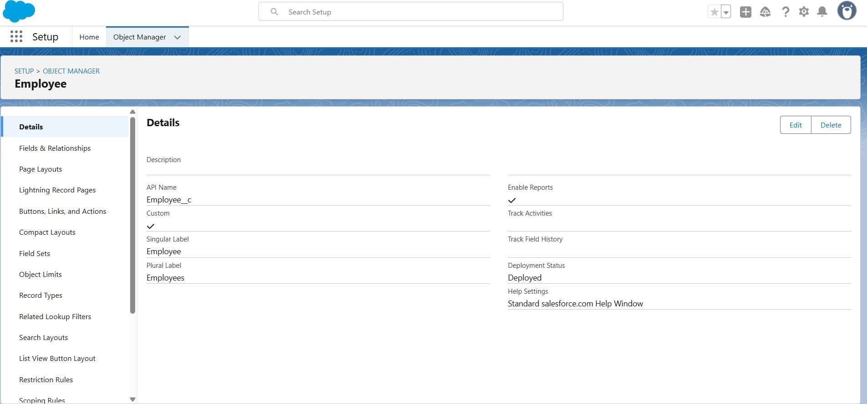

Similarly: ProjectTask, Asset, Asset Service

* + Project Task :

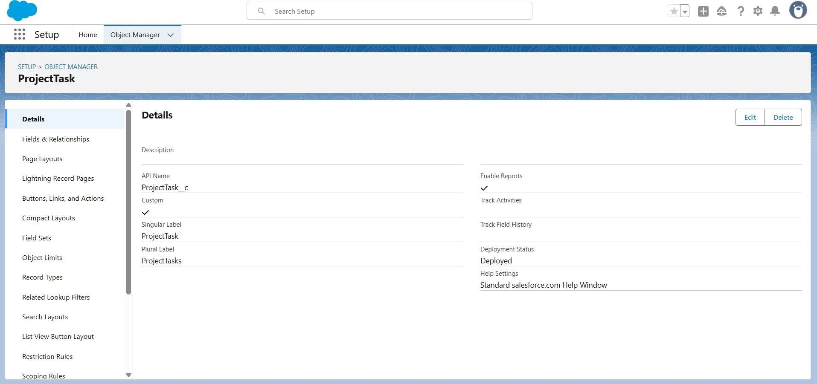

* + Asset:

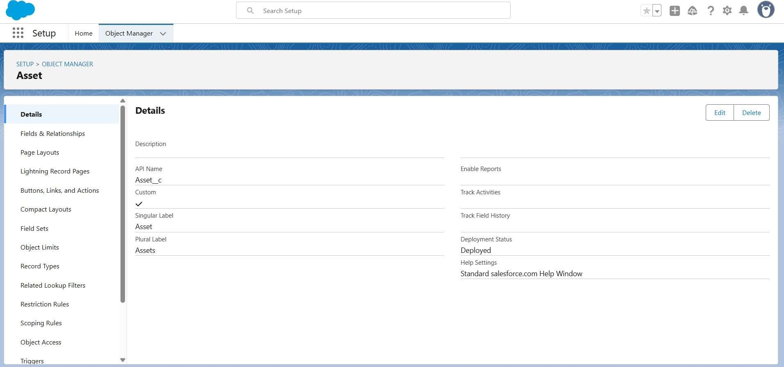

* + Asset Service :

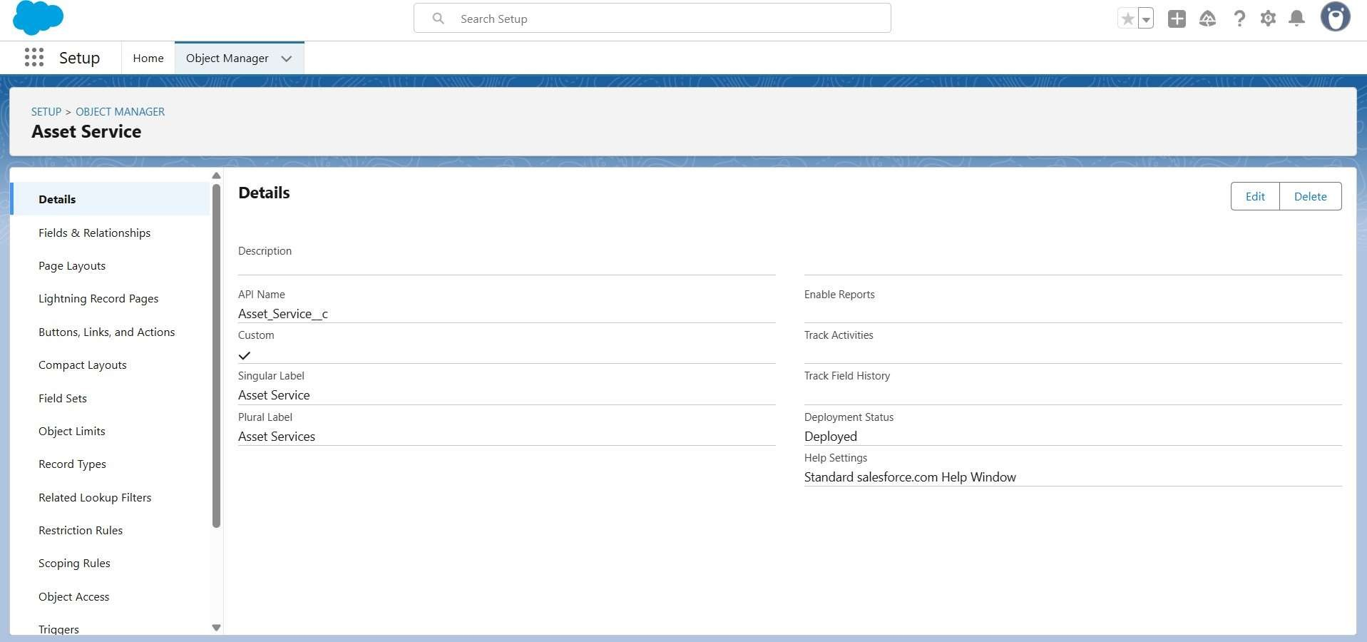

1. CustomTabs and App

* + Tabs for each object

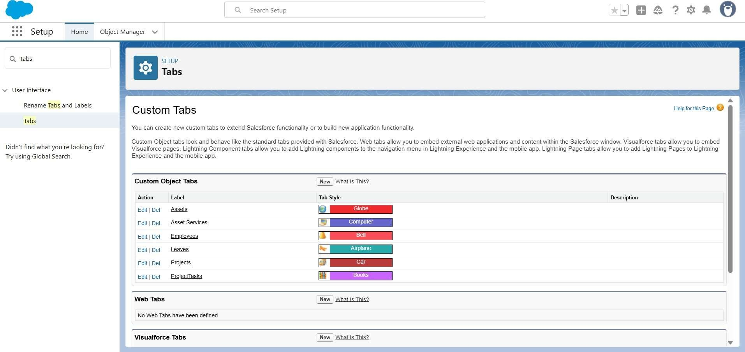

1. Fields and relationships:

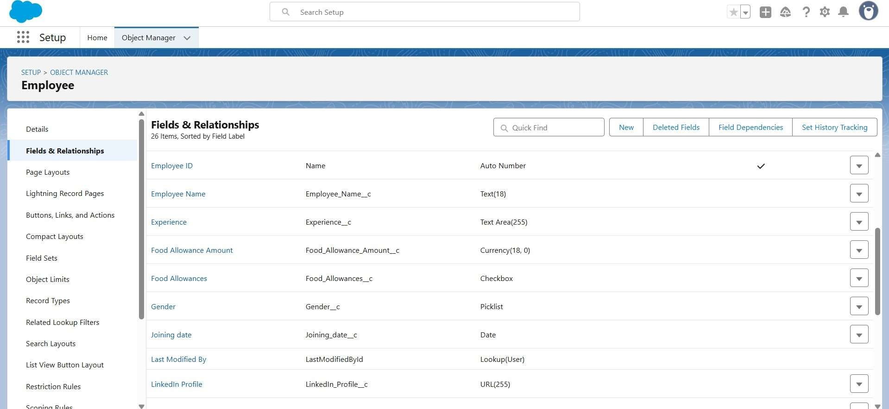

As we can see employee name field in employee object similarly for ProjectTask,

Asset, Asset Service- objects

1. Import Data :

With given URL link of CSV file https://tinyurl.com/SF-Employee-Data



Verified that your data has been imported under batches.

1. Roles:

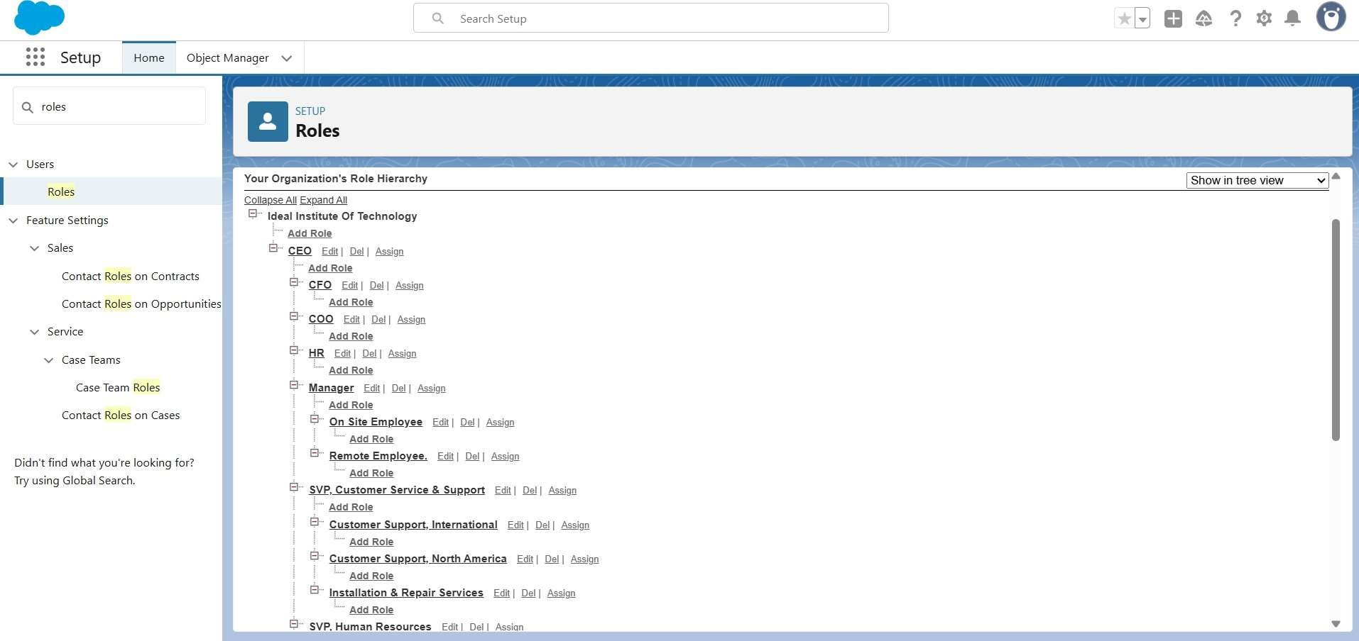

Creating HR Role, Manager, On Site Employee, Remote Employee.

1. Users:

Creating users

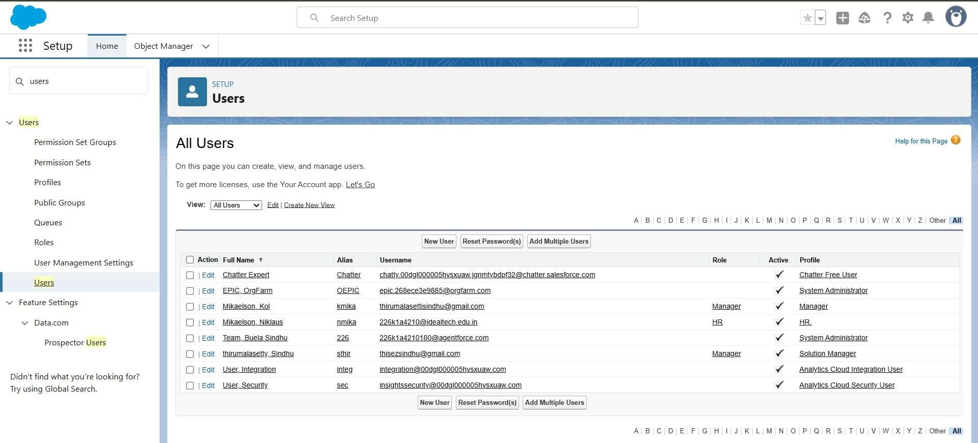

1. Approval process:

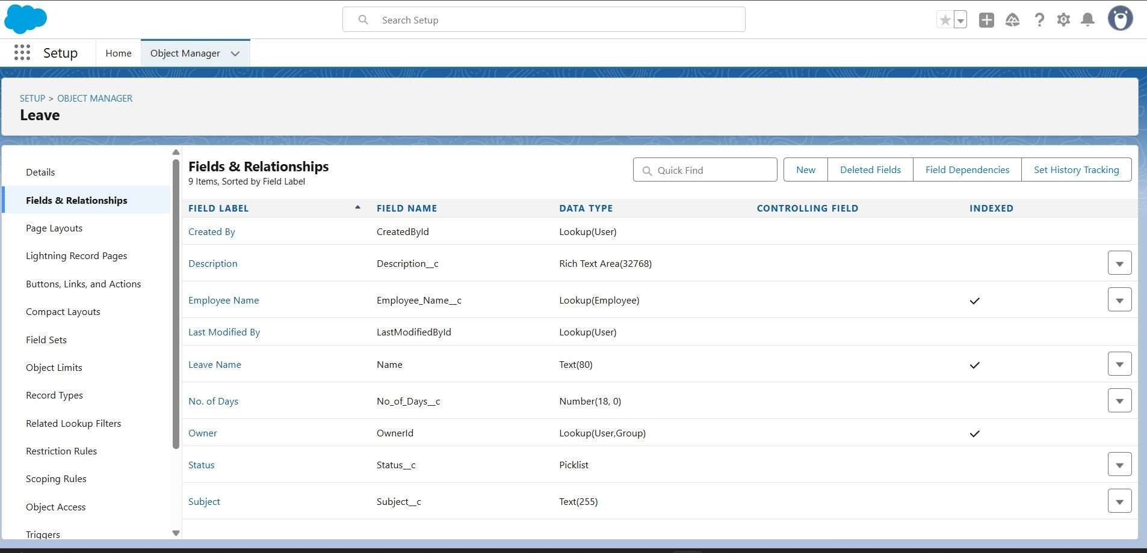

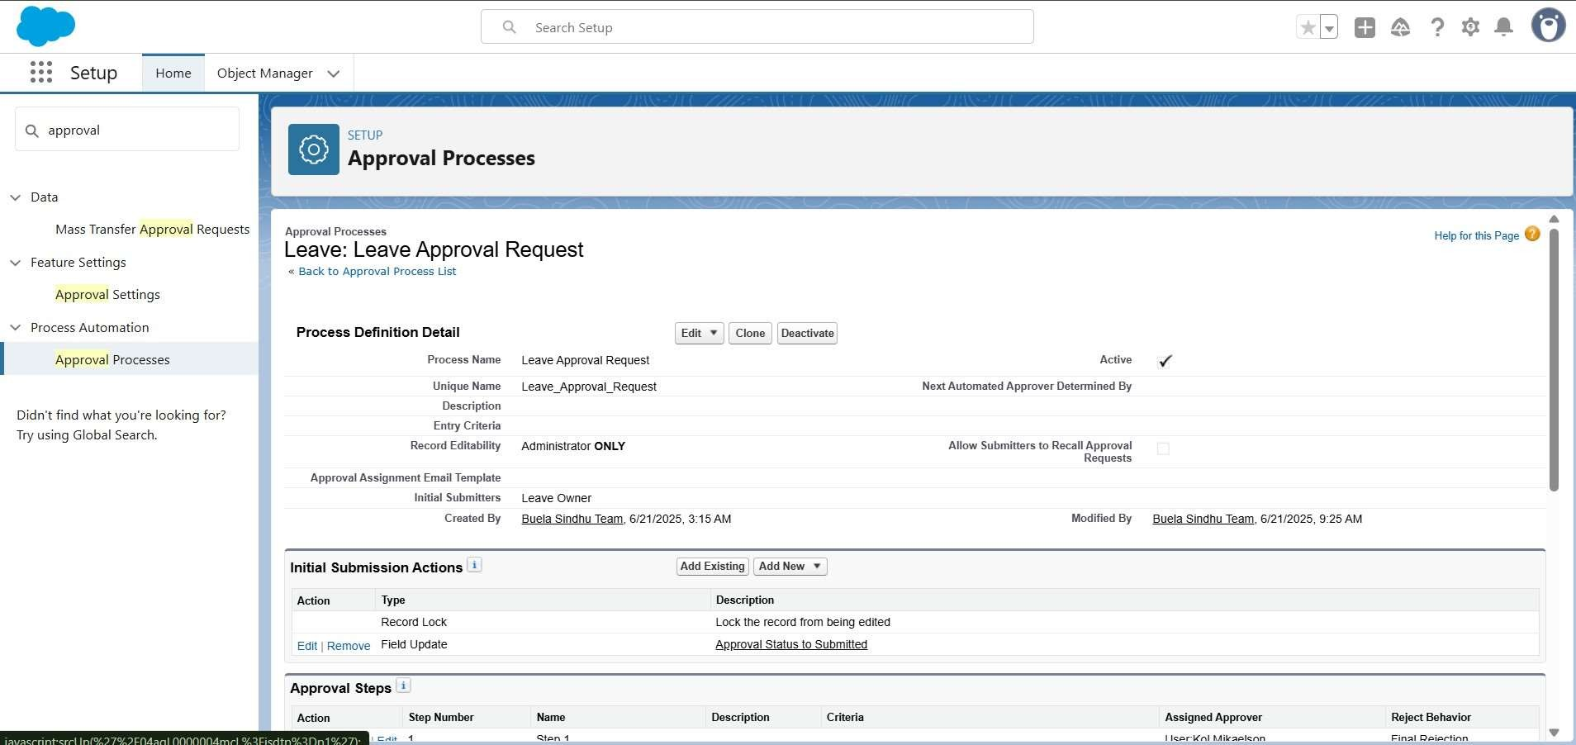

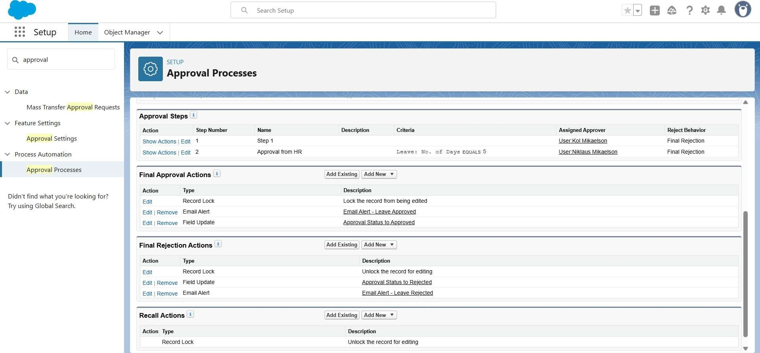

1. Apex Trigger: EmpInsert.apxt

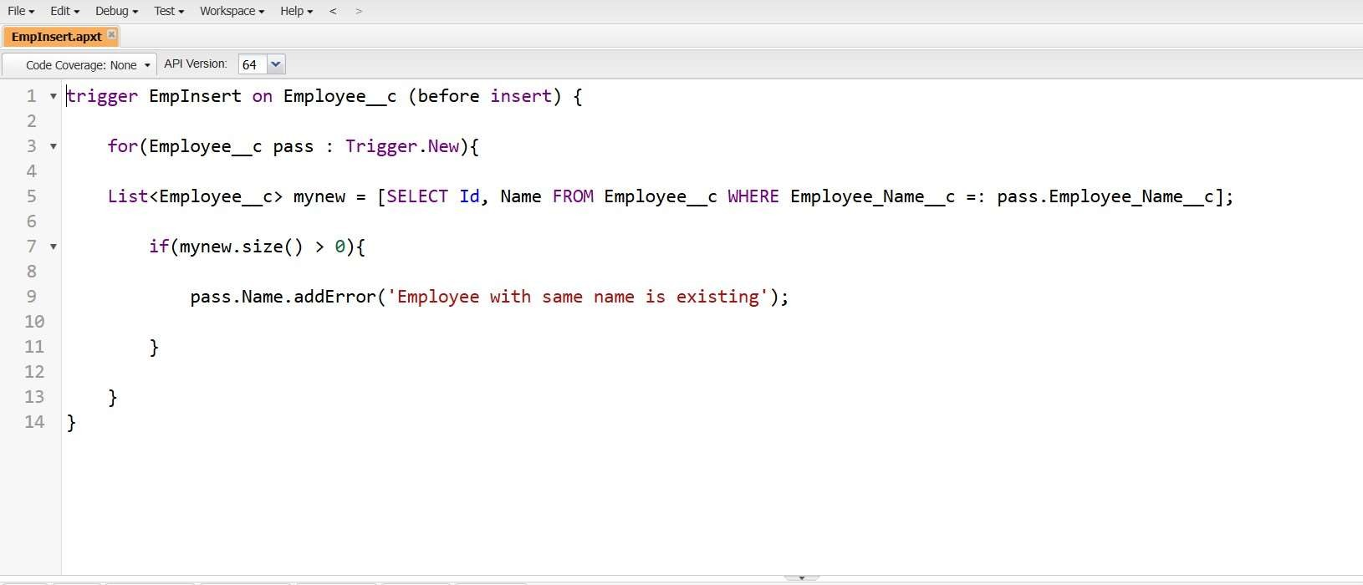

1. Testing the Trigger:For Activity 1 and try to create a record with the existing Employee Name say “Jackie Chan

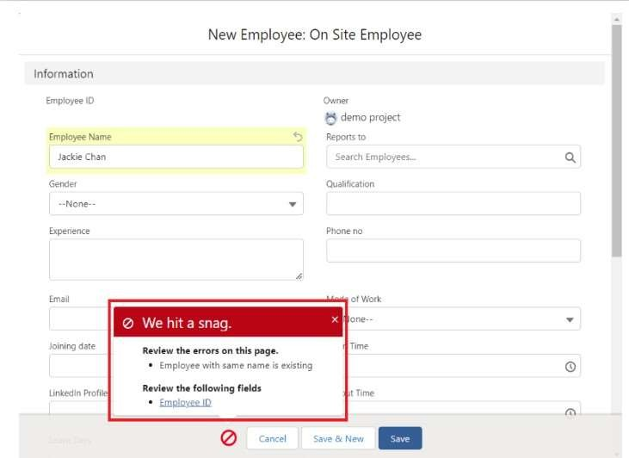

ADVANTAGES & DISADVANTAGES

Advantages of Salesforce Workforce Administration Solution

1. Cloud-Based and Scalable o Accessible from anywhere, supports remote work.
   * Easily scales as your organization grows.
2. Customizable Workflows
   * You can automate HR processes like onboarding, leave approvals, performance tracking, etc., to match your internal operations.
3. Integration with Other Systems
   * Easily integrates with payroll, ERP, attendance, and third-party HR tools (like Workday, ADP, etc.).
4. Data Centralization and Real-Time Updates o All employee data in one place; updates sync instantly across modules.
5. Security and Compliance o Built-in enterprise-grade security, roles/permissions, and audit trails.
   * Can be configured to support GDPR, HIPAA, and other compliance requirements.

Disadvantages of Salesforce Workforce Administration Solution

1. High Cost
   * Licensing, implementation, and ongoing customization can be expensive, especially for SMEs.
2. Complex Initial Setup o Requires skilled Salesforce developers/admins for proper setup and customization.
3. May Require Third-Party Tools
   * Out-of-the-box HR functionality is limited; you may need to use Salesforce AppExchange solutions or build custom apps.
4. User Training and Adoption
   * Non-technical HR staff may find the interface complex at first. Regular training is required.
5. Not a Dedicated HR System
   * Unlike platforms like Workday or SAP SuccessFactors, Salesforce is not natively built for HR, so you have to customize it heavily or use HR apps built on Salesforce.

CONCLUSION:

Conclusion of Workforce Administration Solution

Salesforce Project

Implementing a Workforce Administration Solution using Salesforce provides a flexible, scalable, and cloud-based platform that can be tailored to meet the complex needs of HR and workforce management. With strong capabilities in automation, integration, and data analytics, Salesforce enables organizations to streamline processes such as onboarding, attendance tracking, performance reviews, and employee lifecycle management.

However, Salesforce is not a dedicated HR platform and requires significant customization or integration with third- party applications to deliver full HR functionality. Additionally, the cost, complexity, and need for skilled administrators can be challenging, especially for smaller organizations or those with limited technical resources.

In summary, Salesforce is best suited for organizations looking for a highly customizable workforce administration solution, particularly if they are already invested in the Salesforce ecosystem and have the resources to manage ongoing configuration and support. With the right strategy and execution, it can significantly improve workforce efficiency, data visibility, and HR decision-making.

Demo video Link  
 <https://youtu.be/g_T8OiuHTk4?feature=shared>

Git Link

<https://github.com/Ganeshavupati01/WorkForce.git>